1 CALA Host Affiliate Model 1
2 CALA helps you: 1
3 Tell CALA What You Need 1
4 Overview of our Affiliate Model for facilities wishing to host CALA Educational Events 2
5 Booking a CALA Event is SIMPLE and SEAMLESS! 3
6 Benefits of Hosting A CALA Event 5

CALA Host Affiliate Model
If you did not find a current offering for the course, specialty or workshop that you are interested in, on www.calainc.org, why not consider hosting the event at your facility. The new CALA Host Affiliate Model provides all the information and assistance you need to make your event successful.

CALA helps you:
- Organize the training event quickly and efficiently
- Choose the training course, clinic, or workshop that best meets your needs
- Learn about the latest in Aquafitness, Aqua Yoga, Aqua KickBox, Water Running, HydroRider and Healing Waters: Aquatic Post-Rehabilitation trends, research and programming ideas
- Earn income or offset training costs for your facility by hosting events
- Provide options for subsidizing your staff

Tell CALA What You Need
To assist CALA in providing the best service possible, we ask that you complete this 'Training Request Form' and email it back to cala_aqua@mac.com

Overview of our Affiliate Model for facilities wishing to host CALA Educational Events
Below is a quick overview of our, streamlined affiliate model for facilities wishing to host CALA Educational Events. We hope this outline is helpful to you. There are many benefits of hosting a CALA Based Event, and we look forward to speaking with you soon!
- The CALA Host-Affiliate Model was designed to assist facilities when planning quality, educational aquafitness and related events, ensuring a smooth and simple process for all. You can choose to host a CALA Foundations of Vertical Water Training Pre-requisite Course (VWT) and a variety of CALA Specialty Training and Certification Courses: Healing Waters: Aquatic Post-Rehabilitation: Aqua Arthritis & Joint Disorders, Water Running, Aqua Kick Box, Aqua Yoga, Aqua Pre & Post Natal, HydroRider and Introductory Clinics (8 hours) and Continuing Education Workshops (CECS – 2 – 6 hours) (over 100 exciting topics available).
- With this model, we have many wonderful resources for you - Marketing Tips & Techniques to generate additional registrations, Ideas for creating a Facility Centre of Excellence, Sample Checklists to make planning easy.
- Potential Income for your facility! When hosting a CALA Event, facilities receive a percentage of the income collected from registrations. This affiliate income can be used towards paying the CALA Trainer (fees and travel), to subsidize participant and/or staff fees, or to reinvestment in future training opportunities. With regard to travel costs, every effort is made to utilize the skills of locally based trainers.
- To save your facility valuable time, CALA handles all registrations. Participants have the option of calling or emailing to register.
- To provide value and peace of mind, all CALA Host-Affiliate Workshops and Specialty Courses include full Continuing Education Credits- CEC's. There is also the possibility of CEC’s with other fitness organizations (OFC, canfitpro, YMCA, etc).
- To ensure a professional, organized event, Sample Posters are provided; all you need to do is fill in your facility details and we will do the rest!
- To increase your facility¹s exposure, we market and promote your event to our confidential CALA database of members and contacts (through the CALA "Upcoming Events" emails, CALA Website and phone campaigns). Other marketing plans are the responsibility of the facility and we would be pleased to provide success stories and unique ideas from past events.

Booking a CALA Event is SIMPLE and SEAMLESS!
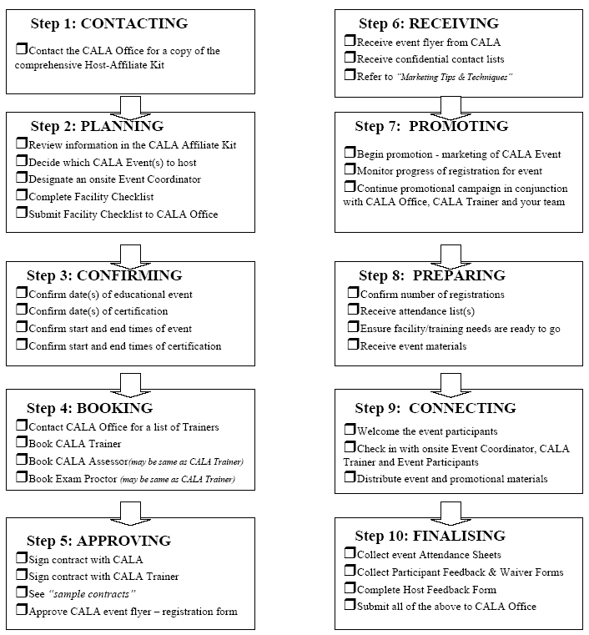

Benefits of Hosting A CALA Event
- Partnering with a firmly established company with a strong reputation for excellence
- Offering state of the art, leading edge programs based on skillful leadership and participant satisfaction
- Earning income for your facility
- Integrating new programs while maintaining and respecting the status quo of existing leaders, trainers and classes
- Streamlining leadership development with a proven system of foundation and specialty courses, conferences, guest classes and workshops
- Saving thousands of dollars by identifying the essential equipment only - learning to use the water as the training tool
- Eliminating storage requirements of equipment
- Providing ongoing research and development
- Producing trend-setting programs to keep leaders and participants satisfied and motivated
- Creating a network of mentors to coach new leaders
- Building a community of leaders and participants who work together to create an inclusive and supportive team spirit
- Selecting appropriate programs for your facility, from a wide range of classes, to meet the diverse needs of the population
- Creating a ‘centre of excellence’ for aquafitness and associated programs within the facility
- Building a library of resources accessible to leaders, participants and other members of the community
- Offering subsidized, custom designed staff training

Please type or print clearly in black ink & email back the completed form to CALA.

Date (yyyy, mm, dd): _______________________

Facility Name
Location: (City and Province)
Your Name
Your Title
Your Phone (include area code)
Your Email

Check the appropriate response(s):
- What training courses are you interested in hosting?
Foundations of Vertical Water Training (VWT) (Pre-requisite Program) Note***
Group Aqua Fitness Specialty Training and Certification (GAF)
Healing Waters: Post Aquatic Rehabilitation Program: Aqua Arthritis Specialty Training and Certification (HW)
Water Running Specialty Training and Certification (WR)
Aqua Kick Box – Centre of Power Specialty Training and Certification (AKB)
Aqua Natal Specialty Workshop for Continuing Education Credits (PPN)
Older Adults Specialty Workshop for Continuing Education Credits
Other Workshops – 3–6hours - choice topic or need to be addressed
Conference: Regional or National
*** Note: In the case where potential course participants have prior education and experience with respect to fitness leadership, CALA offers a “Letter of Acceptance” that must be completed in order to bypass participation in the pre-requisite Foundations of Vertical Water Training Course. Once the candidate is accepted and given permission to bypass the VWT course, they must purchase a VWT manual and successfully complete an open book theory exam before proceeding to a Specialty Training and Certification course.

- When you would like to host the event?
Within the next month
Within the next 1-3 months
Within the next 6 months
Immediately
Specific date you have in mind: ( )

Has your facility hosted a CALA event before? _ _yes ____no ____not sure
If yes, which one: ________________________________________________
When (approx. date)

- How many participants will be attending? ____________________________

- Would you like to invite outside instructors/participants to the course? (This is a great way to increase revenue for hosting the course and provides valuable exposure to your facility) ___yes ____no ____not sure

- What are your goals in hosting this event? (check all that apply)
Address the need of shortage of instructors at our facility
Training for our new or current staff who require high quality certification
Continuing education and motivation for our instructor team
Earn revenue for our facility
Ongoing training and certification to create a centre of excellence at our facility
Increase programming opportunities at our facility
Other:

- What is your budget for this event? (approx.) ____________________________

- How did you hear about CALA?

- When is the best time for the CALA Host Affiliate Manager to follow up with you?

Day: Any day through the work week in the mornings or at home in the evenings.

______ AM or _______ PM:

Prefer : Phone______________ Email____________ either____

Thank you!
Charlene Kopansky, President and Owner

Please email this information back to the CALA Office.
Your request is important to us and we will follow up
within 24-48 hours.

cala_aqua@mac.com www.calainc.org

