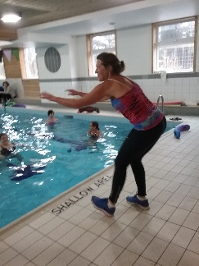
This is a suggested guideline.
Use the topics that make your posting as clear as possible.
Review current postings on CALA site for ideas what others are posting.
Name of Position (required)
Facility (private or public)
Description of position (required)
Audience/Participants (required)
Size and length of classes
Number of classes available
Lifeguard
Dates and Times of classes
Pool details (length, lanes, depth, ladder, accessible, water wheelchair, lifeguards, drop-in or registered, picture of facility)
Credentials (general Aquafitness, specialties ex: Arthritis, Natal, Fibromyalgia,)
Experience (years, special audiences)
Insurance (require own or covered under facility)
Police Records Check
Vaccine requirement
Training ex: OADA, WHIMS, CPR, FIRST AID
Compensation
Benefits
What you offer
How to apply
Contact information
Full address of facility
Review process, interview and demonstration class

